PHP further ways to use functions workshop

You can use functions to improve the efficiency of server-side scripts in many ways. So far, for example you have created functions to establish a connection to a database, validate form input, set and read sessions etc. In this workshop you will look at some more ways to use functions in web development. Specifically you will use them to generate parts of a web page, e.g. the ‘header’, ‘footer’ and ‘navigation menu’.

In the following exercises remember that you will then need to upload copies of each file you create onto your web space on the newnumyspace web server and that to test them you need to enter the appropriate web address into the address bar of your web browser.

Exercise 1: adding to your functions script
In this exercise we are going to take the following example html code and make functions to create its various parts. Note: DO NOT copy this code altogether and make a web page from it.

<!doctype html>
<html lang="en">
<head>
<meta charset="UTF-8">
<title>Review it!</title>
<link href="review.css" rel="stylesheet" type="text/css">
</head>
<body>
<div id="gridContainer">
<header>
<h1>Review it!</h1>
</header>
<nav>
<h2>Browse</h2>
<ul>
<li><a href="index.php">Home</a></li>
<li><a href="books.php">Books</a></li>
<li><a href="dvd.php">DVD</a></li>
<li><a href="games.php">Games</a></li>
</ul>
</nav>
<main>
<h2>Add your reviews of the following and more</h2>
<h3>Jamie's America</h3>
<p>Jamie will try real American food and meet the most
interesting cooks and producers that this vast country has to
offer. His epic journey will take him to the heart of America:
its people, culture, music and, most importantly, its food. As
well as being a visually stunning journey, "Jamie's America" is
a practical cookbook, with each chapter focusing on the food and
recipes of a different state. Add review</p>
</main>
<footer>
<p>Taken from the whsmith web site</p>
</footer>
</div>
</body>
</html>

- Modify your PHP script called functions.php (or create one if you don’t have one) and enter / copy the following code into it and save it

function makePageStart() {
$pageStartContent = <<<PAGESTART
<!doctype html>
<html lang="en">
<head>
<meta charset="UTF-8">
<title>Review it!</title>
<link href="review.css" rel="stylesheet" type="text/css">
</head>
<body>
<div id="gridContainer">
PAGESTART;
$pageStartContent .="\n";
return $pageStartContent;
}

function makeHeader(){
$headContent = <<<HEAD
<header>
<h1>Review it!</h1>
</header>
HEAD;
$headContent .="\n";
return $headContent;
}

function makeNavMenu() {
$navMenuContent = <<<NAVMENU
<nav>
<h2>Browse</h2>
<ul>
<li><a href="index.php">Home</a></li>
<li><a href="books.php">Books</a></li>
<li><a href="dvd.php">DVD</a></li>
<li><a href="games.php">Games</a></li>
</ul>
</nav>
NAVMENU;
$navMenuContent .= "\n";
return $navMenuContent;
}

function makeMainArea() {
$mainContent = <<<MAINAREA
<main>
<h2>Add your reviews of the following and more</h2>
<h3>Jamie's America</h3>
<p>Jamie will try real American food and meet the most
interesting cooks and producers that this vast country has to
offer. His epic journey will take him to the heart of America:
its people, culture, music and, most importantly, its food. As
well as being a visually stunning journey, "Jamie's America"
is a practical cookbook, with each chapter focusing on the
food and recipes of a different state. Add review</p>
</main>
MAINAREA;
$mainContent .= "\n";
return $mainContent;
}

function makeFooter() {
$footContent = <<<FOOT
<footer>
<p>Product details taken from the whsmith web site</p>
</footer>
FOOT;
$footContent .="\n";
return $footContent;
}

function makePageEnd() {
return "</div>\n</body>\n</html>";
}

- Create a new PHP script called index.php and enter / copy the following code into it and save it

<?php
require_once('functions.php');
echo makePageStart();
echo makeHeader();
echo makeNavMenu();
echo makeMainArea();
echo makeFooter();
echo makePageEnd();
?>

- Download a copy of the file review.css from blackboard and save it into the same folder as functions.php and index.php

- Upload functions.php, index.php and review.css onto your web space on the newnumyspace web server and test index.php in a browser to see whether it works as expected. You should see something like the following:

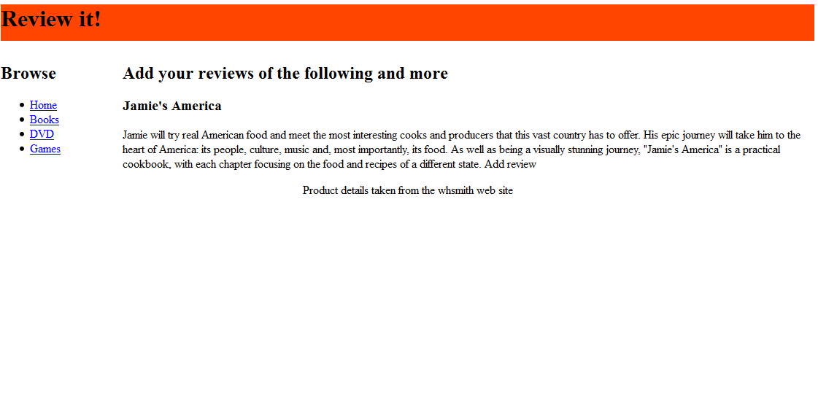

If you view the source of the web page that has been created and displayed in the web browser, you will see that it has the same content as the example html code that was referred to at the beginning of the exercise. The page has been generated by the functions that we created.

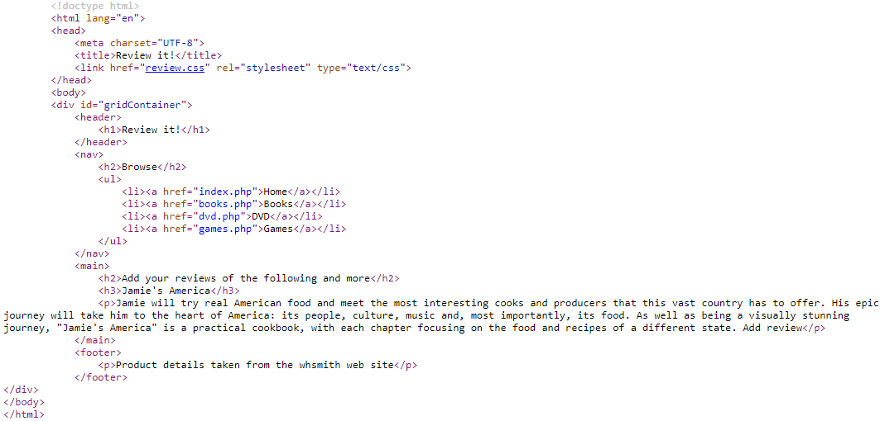

Exercise 2: making the functions more re-usable
What we have done so far works but it is not very flexible as the functions would only ever produce the same web page content. To start to make the functions more re-usable (for different web pages) we are going to modify some of them so that they can accept argument values that will be used to set parts of the web page such as the title and the CSS file to use.

- Modify the code for the makeNavMenu function in the functions.php file by making the changes highlighted in bold below

function makeNavMenu($navMenuHeader) {
$navMenuContent = <<<NAVMENU
<nav>
<h2>$navMenuHeader</h2>
<ul>
<li><a href="index.php">Home</a></li>
<li><a href="books.php">Books</a></li>
<li><a href="dvd.php">DVD</a></li>
<li><a href="games.php">Games</a></li>
</ul>
</nav>
NAVMENU;
$navMenuContent .= "\n";
return $navMenuContent;
}

- Modify the code in the index.php file to change the call to the makeMenu function so that an argument value to be used as the menu’s h2 sub-heading is passed to it as follows:

echo makeNavMenu("Categories");

You could of course use any argument value that you liked.

- Test the updated home page. The menu sub-heading should have changed

- Now modify the code and the call to the makeFooter function so that the footer text inside the p tags is specified using an argument and test the changes (the web page should look the same). Hint: the call to the function in the index.php file should look like the following:

echo makeFooter("Product details taken from the whsmith web site");

- Modify the code of and the call to the makePageStart function so that the title of the page (to go between the opening and closing title tags) and the CSS file to use are specified using arguments. Test the changes (the web page should look the same). Hint: the call to the function in the index.php file should look like the following:

echo makePageStart("Review it!", "review.css");

- Modify the code of and the call to the makeHeader function so that the text for the h1 heading is specified using an argument. Test the changes (the web page should look the same). Hint: the call to the function in the index.php file should look like the following:

echo makeHeader("My Reviews");

- We are now going to modify the code so that we can allow the ‘main’ page content to be varied between pages

  - Remove the function makeMainArea() from the functions.php script

  - Add the following new function to functions.php to create the start of the main content area

function startMain() {
return "<main>\n";
}

  - Add the following new function to functions.php to create the end of the main content area

function endMain() {
return "</main>\n";
}

  - Modify the code in index.php as follows:

- Remove the call to makeMainArea()
- To call startMain() and endMain()
- By adding the content that we want in the ‘main’ area of the page (i.e. the heading 2, heading 3 and the paragraph from the code below) after the call to startMain()

The code in index.php should now be as follows:

<?php
require_once('functions.php');
echo makePageStart("Review it!", "review.css");
echo makeHeader("Review it!");
echo makeNavMenu("Categories");
echo startMain();
?>
<h2>Add your reviews of the following and more</h2>
<h3>Jamie's America</h3>
<p>Jamie will try real American food and meet the most interesting cooks and producers that this vast country has to offer. His epic journey will take him to the heart of America: its people, culture, music and, most importantly, its food. As well as being a visually stunning journey, "Jamie's America" is a practical cookbook, with each chapter focusing on the food and recipes of a different state. Add review</p>
<?php
echo endMain();
echo makeFooter("Product details taken from the whsmith web site");
echo makePageEnd();
?>

- Test the modified home page. It should look just as it did before (as we are creating the same content but in a different way)

- Create and test a new PHP script called books.php that uses the same functions as the index.php script, but passes different values into the makePageStart and makeHeader functions and includes different ‘main’ body content to create a books page. The books.php script should have content like the following.

<?php
require_once('functions.php');
echo makePageStart("Review it! Books Page", "review.css");
echo makeHeader("Review it!");
echo makeNavMenu("Categories");
echo startMain();
?>
<h2>Books</h2>
<h3>A book title</h3>
<p>Info about a book...</p>
<?php
echo endMain();
echo makeFooter("Product details are made up");
echo makePageEnd();
?>

When viewed in a web browser books.php should look something like the following:



Exercise 3: a more flexible re-usable navigation menu
The makeNavMenu function that we have created allows some flexibility, you can vary the sub-heading text, but to make it usable for different web projects (different web sites) we would need to be able to vary the links and the link text.

- In functions.php modify the code for the makeNavMenu function so that it accepts an associate array of links and link text as follows:

  - Change the function so that is able to accept two parameters – the navigation menu heading 2 and an associative array of links and link text, e.g.

function makeNavMenu($navMenuHeader, array $links) {
....

The call to the function would now need to look something like:

echo makeNavMenu("Categories", array("index.php" => "Home", "books.php" => "Books", "dvd.php" => "DVD", "games.php" => "Games"));

  - Change the makeNavMenu function so that it loops through the associative array and creates one set of li tags per link, e.g.

<li><a href="index.php">Home</a></li>
<li><a href="books.php">Books</a></li>
<li><a href="dvd.php">DVD</a></li>
<li><a href="games.php">Games</a></li>

Hint: this is similar to the method used in the select list example in the lecture slides on functions.

- Modify the code in index.php and books.php so that the calls to makeNavMenu include argument values for the navigation menu heading 2 text and an array of links and link text as follows:

echo makeNavMenu("Categories", array("index.php" => "Home", "books.php" => "Books", "dvd.php" => "DVD", "games.php" => "Games"));

Note: in a browser the web pages produced should look the same as before of course.

- Create a new PHP script that uses the modified functions.php script to build a new web page with the following characteristics

  - Title: Newcastle Sports - Products
  - CSS file: sports.css
  - Header h1 text: Newcastle Sports
  - Navigation menu h2 heading text: Menu
  - The following links:
<li><a href="about.php">About</a></li>
<li><a href="products.php">Products</a></li>
<li><a href="extras.php">Extras</a></li>
<li><a href="order.php">Ordering</a></li>
  - The main area of the page should have
    - The h2 heading <h2>Current products</h2>
    - Two paragraphs of made up product text
  - Footer text: Copyright 2019

